Paper Title
——Subtitle as needed

Abstract: This document gives formatting instructions for authors preparing papers for publication in this journal. All authors must follow the instructions given in this document for the papers to be published. You can use this document as both an instruction set and as a template into which you can type your own text.
Keywords: Initials in Capitals, Separate with Semicolons …
- Introduction
This document is a template. An electronic copy can be downloaded from the journal website. For questions on paper guidelines, please contact the publications committee as indicated on the journal website. Information about final paper submission is available from the journal website.
- Page Layout
An easy way to comply with the journal paper formatting requirements is to use this document as a template and simply type your text into it.
2.1 Page Layout
Your paper must use a page size corresponding to A4 which is 210mm (8.27") wide and 297mm (11.69") long. The margins must be set as follows:
- Left = Right=25.4mm
- Page Style
3.1 Text Font of Entire Document
The entire document should be in Times New Roman font. Other font types may be used if needed for special purposes.
Recommended font sizes are shown in Table 1.
3.2 Title and Author Details
Every word in a title must be capitalized except for short minor words such as “a”, “an”, “and”, “as”, “at”, “by”, “for”, “from”, “if”, “in”, “into”, “on”, “or”, “of”, “the”, “to”, “with”.
Author details must not show any professional title (e.g. Managing Director), any academic title (e.g. Dr.) or any membership of any professional organization (e.g. Senior Member AIP).
Each affiliation must include, at the very least, the name of the company/university/institution and the name of the country where the author is based (e.g. American Institute of Physics, USA).
An E-mail address is compulsory for the corresponding author.
3.3 Section Headings
No more than 3 levels of headings should be used. Every word in a heading must be capitalized except for short minor words as listed above.
table 1 font sizes for papers
Font Size | Appearance
Font Size | Regular | Bold | Other
9 | author affiliation, author email address, abstract body, reference item. | abstract heading (also in Bold), keywords | Special purpose
10 | table caption (in Small Caps), figure caption, paragraph, author bio.
10.5 | body
12 |  | Level-1 heading
14 | subtitle | Level-1 heading
24 |  | paper title
- Level-1 Headings
A Level-1 heading must be left-justified.
- Level-2 Headings
A level-2 heading must be in Italics, left-justified. For example, see heading “Section Headings” above.
- Level-3 Headings
A Level-3 heading must be indented, in Italics and numbered with an Arabic numeral followed by a right parenthesis. For example, this paragraph begins with a Level-3 heading.
3.4 Figures and Tables
Figures and tables must be centered in the column. Any table or figure that takes up more than 1 column width must be positioned either at the top or at the bottom of the page.
Graphics may be full color. All colors will be retained on the CDROM. Graphics must not use stipple fill patterns because they may not be reproduced properly. Please use only solid fill colors which contrast well both on screen and on a black-and-white hardcopy, as shown in Fig. 1.
Please check all figures in your paper both on screen and on a black-and-white hardcopy. When you check your paper on a black-and-white hardcopy, please ensure that:the colors used in each figure contrast well;
- the image used in each figure is clear;
- all text labels in each figure are legible.
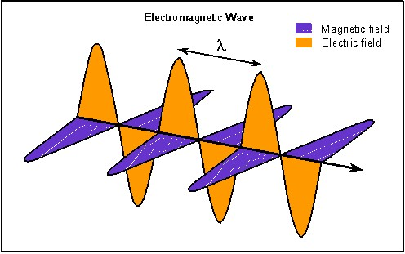
FIG. 1 USE ONLY SOLID FILL COLORS
3.5 Figure Captions
Figures must be numbered using Arabic numerals. Figure captions must be in 10 pt Regular font. All captions should be centered. Captions with figure numbers must be placed after their associated figures.
3.6 Table Captions
Tables must be numbered using uppercase Arabic numerals. Table captions must be centered and in 10 pt Regular font with Small Caps. Every word in a table caption must be capitalized except for short minor words as listed in Title and Author Detail section. Captions with table numbers must be placed before their associated tables, as shown in Table 1.
3.7 Page Numbers, Headers and Footers
Page numbers, headers, and footers must not be used.
3.8 Links and Bookmarks
All hypertext links and section bookmarks will be removed from papers during the processing of papers for publication. If you need to refer to an Internet email address or URL in your paper, you must type out the address or URL fully in Regular font.
- Conclusions
.
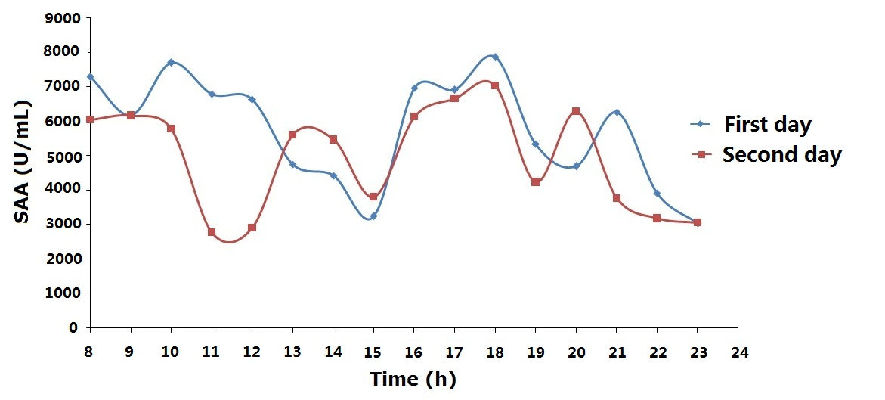
FIG. 2 FIGURES CENTERED IN COLUMN

Acknowledgment
The heading of the Acknowledgment section and the References section must not be numbered.
Number footnotes separately in superscripts. Place the actual footnote at the bottom of the column in which it was cited. Do not put footnotes in the reference list. Use letters for table footnotes.
Papers that have not been published, even if they have been submitted for publication, should be cited as “unpublished” Papers that have been accepted for publication should be cited as “in press”.

References
Pernice, W. H. P., Payne, F. P., & Gallagher, D. F. G. (2007). Numerical investigation of field enhancement by metal nano-particles using a hybrid FDTD-PSTD algorithm. optics express, 15(18), 11433-11443.

NOTE: Requirements for citing references:
1. Please refer to APA format for reference list.
2. The citation of other literature in the main text of the article also needs to follow the standard APA format:
Regarding the standard requirements for APA format, please refer to the following instructions:
https://www.mendeley.com/guides/apa-citation-guide/

